Bash Scripting Assignment-02
1.Create a bash script to check if a directory is available or not.
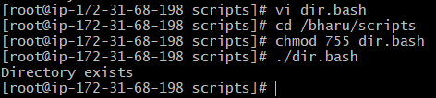
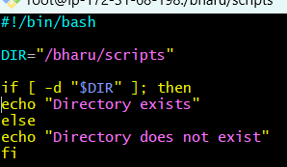
2. Create a bash script to create multiple files.

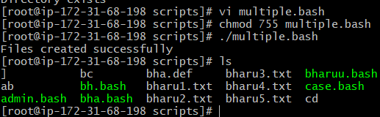
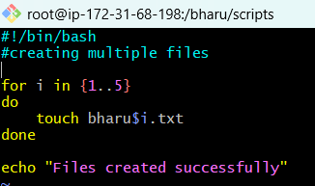
3.Create a bash script to take a backup of a directory.

4.Create a bash script to install Nginx on an EC2 server.
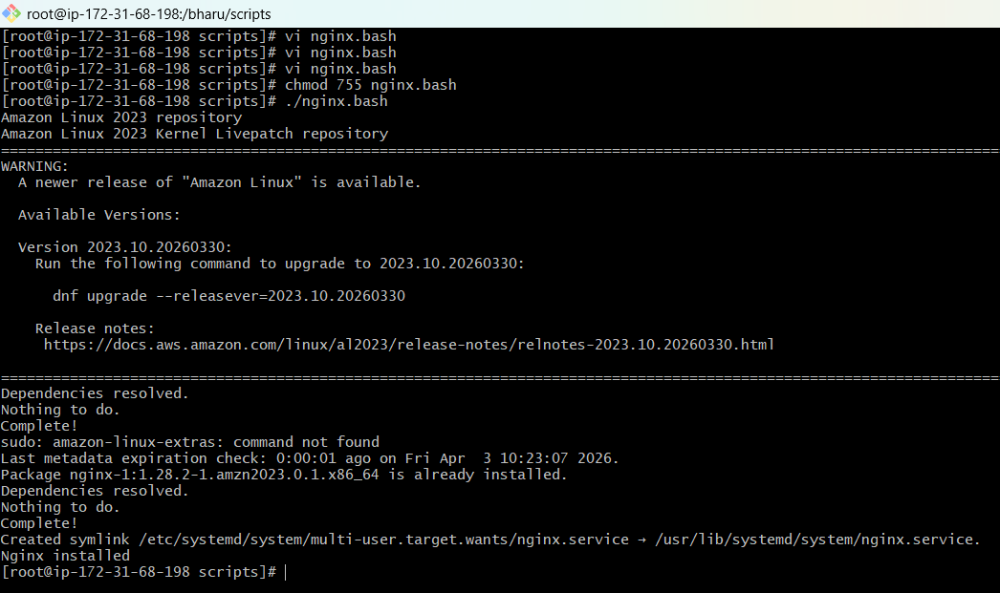
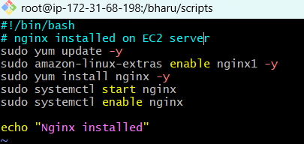
5. Create a bash script to install Apache Tomcat on an EC2 server.

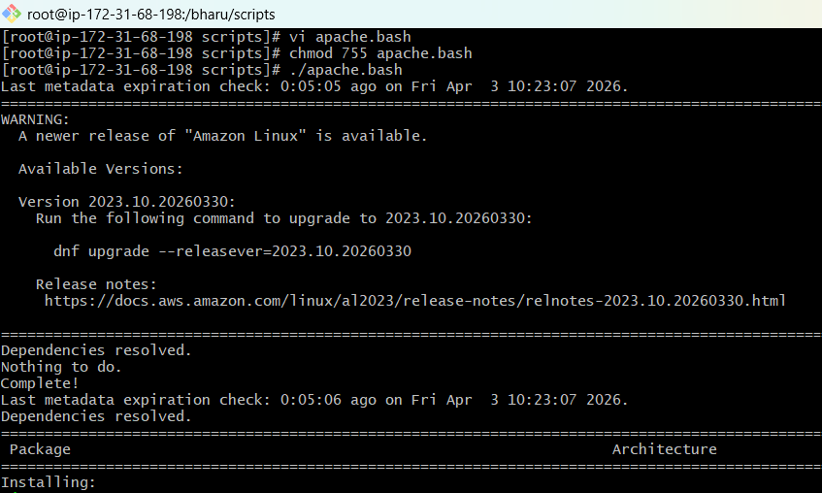
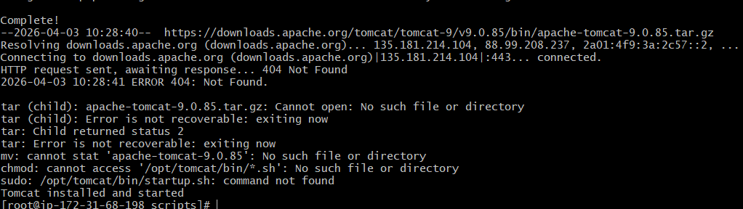
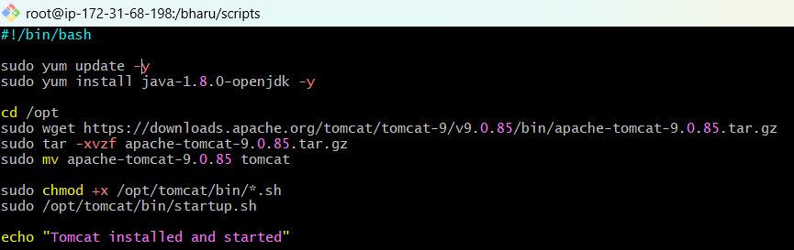
6.Create a bash script to check if the Nginx service is running, if not running then script should start the service.
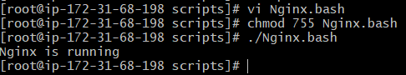
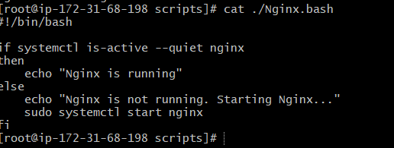
7)Create a bash script for a calculator.

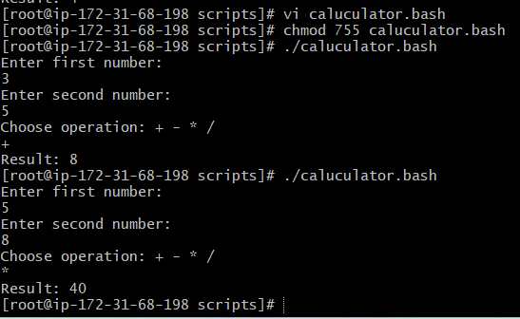
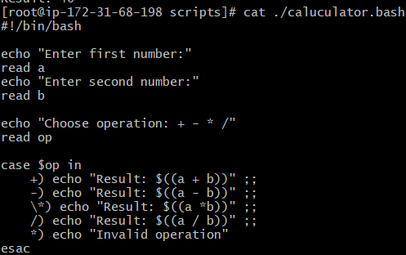
8)Create a bash script to check if a directory exists, if not then create a directory.
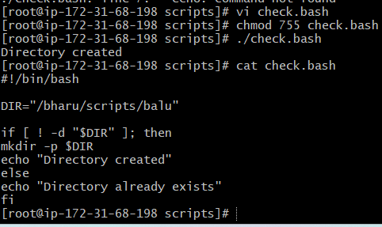

8)Create a bash script to delete the last 3 lines of a file.
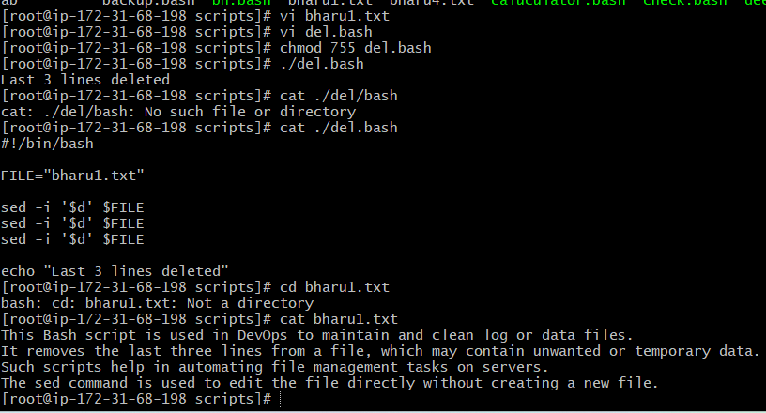
8.1)Bash script to monitor cpu and if it is more than 80% then send email notification.
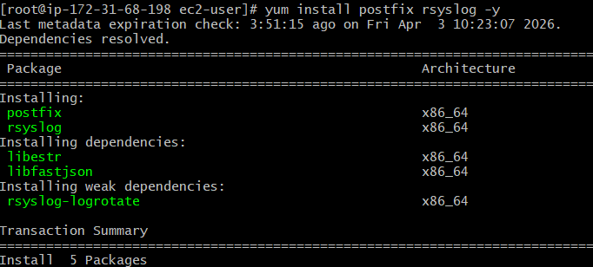
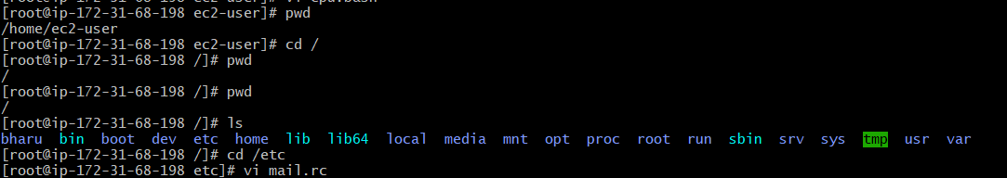
After vi mail.rc giving we get below configuration.. set to go last line we can enter this in last lines with our mail and password.
smtp=smtp://smtp.gmail.com:587
set smtp-use-starttls
set ssl-verify=ignore
set smtp-auth=login
set smtp-auth-user=bharumanipati31@gmail.com
set smtp-auth-password=your_app_password
set from=" bharumanipati31@gmail.com"
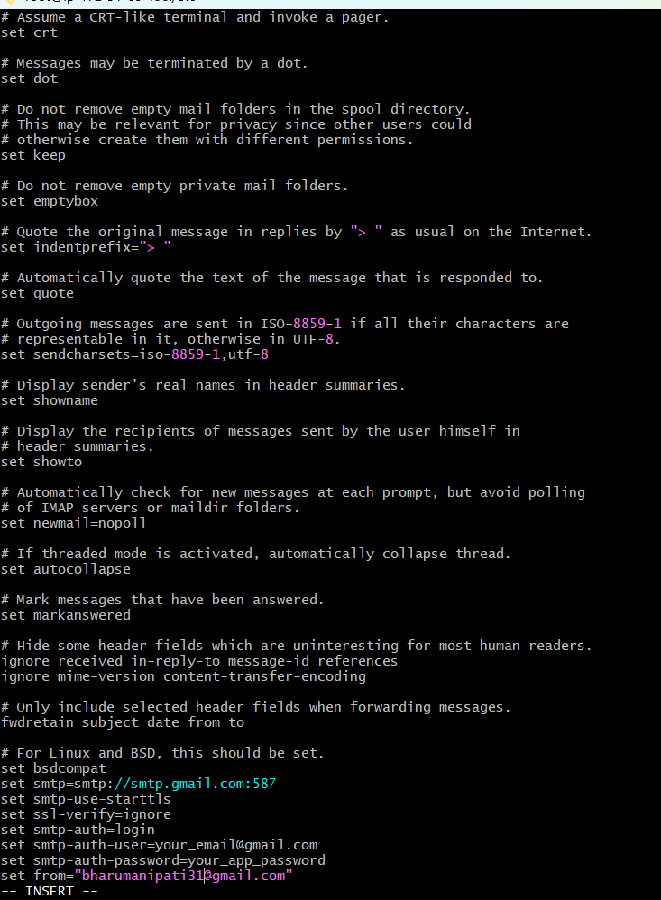
In this we have to goo last line of the page and enter our mail id and password …that password should be generated in google security…..we have to go manage google security set 1st 2 step verification turn on go to settingsset passwordcreate mail and then generated automate password and that password should be enter in the git bash from the 2nd last line we have to enter without space that password in gitbash then :wq!

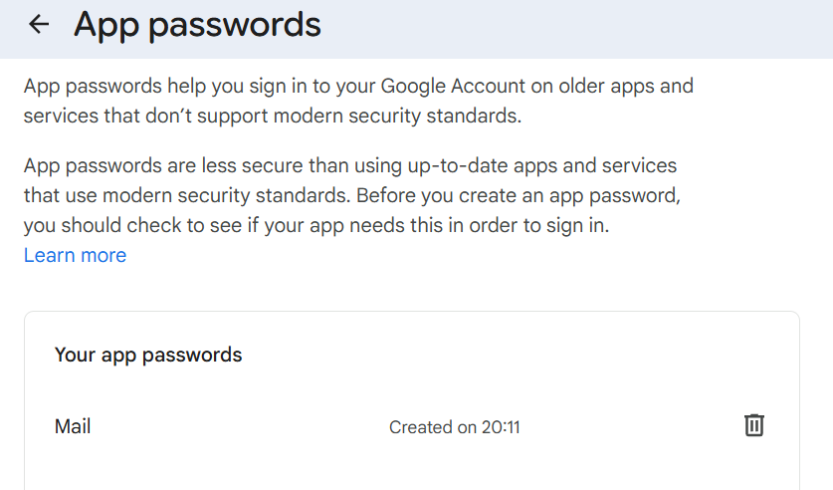
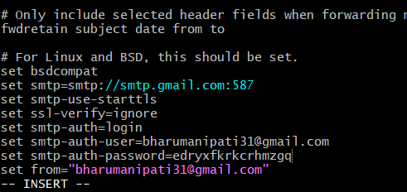
After enter this we have go to vi mail.rc
We have to given below command after that..
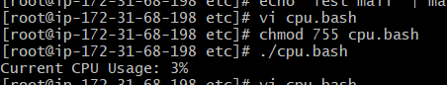

We have to get CPU alert message through mail…shown in below..
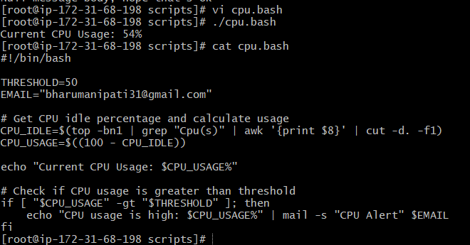
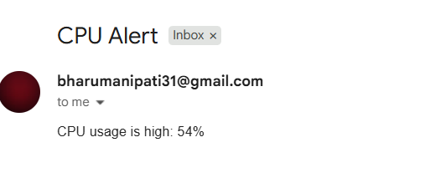

8.2) Bash script to monitor disk space and if it is more than 80% then send email notification.
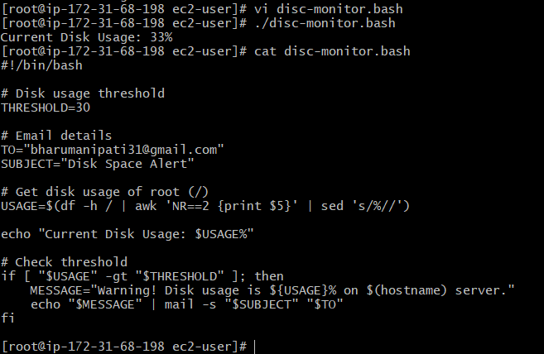
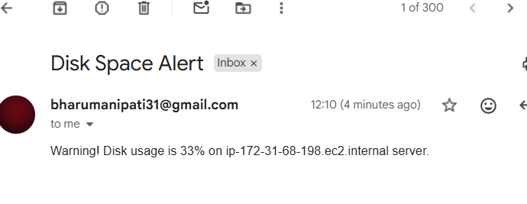

8.3) Bash script to monitor memory and if it is more than 80% then send email notification.
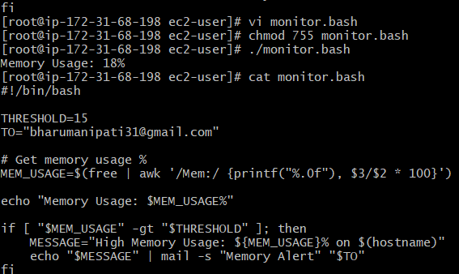
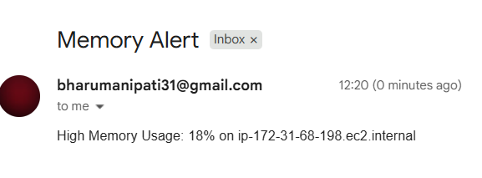

Cronjobs Exercise
We can use
sudo yum install cronie -y
We can install cronie 1st then
sudo systemctl status crond
I have check the running status of cron and active running we have to go
list crontab - crontab-l
edit crontab -crontab-e
remove crontab -crontab-r
backup crontab – crontab-l>crontab-backup

What is Cronjob and crontab?
A cron job is a scheduled task in Linux that runs automatically at a specific time or interval.
crontab = cron table It is a file where all cron jobs are stored 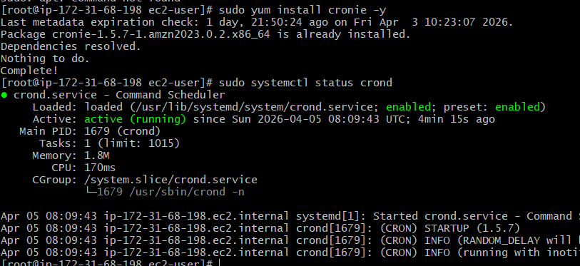
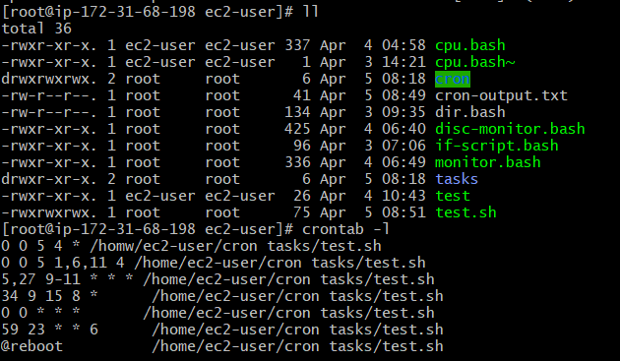

We have to enter crontab -e
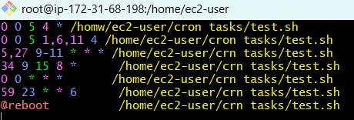
Enter these commands for these tasks:
April 5th Midnight
5th of Every November, January, June if it is a Thursday
- At 05 and 27th minutes of 9, 10, 11 hours every day
34 minutes of 9th hour on 15th August
Every midnight
- Every Weekend (Saturday night 11:59 PM)
- After every reboot
If we want to stop the nginx using systemctl stop nginx &
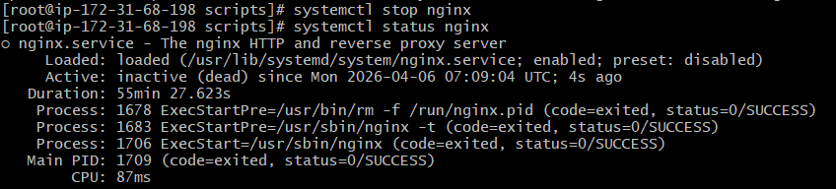enter the crontab -e to enter the matter for 7.15 time I want to run the script we can give crontab -e
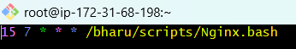 enter this command and execute we check after the nginx status a time f 7.15 we see that status was on and we see the command was executed with particular time given in the below..
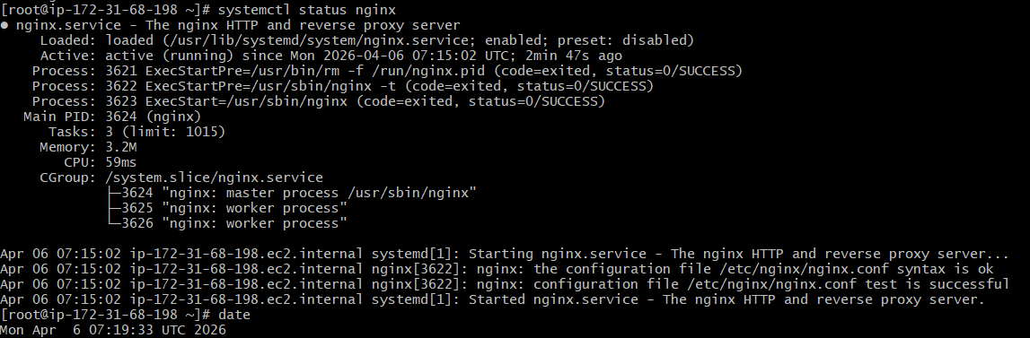
In that test.bash file we have to get inside commands
free -m,ps -ef,df
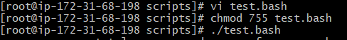
Below is the output:
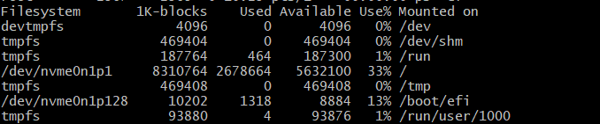
We get the log details for that purpose we have to give cd /var/spool/mail/root
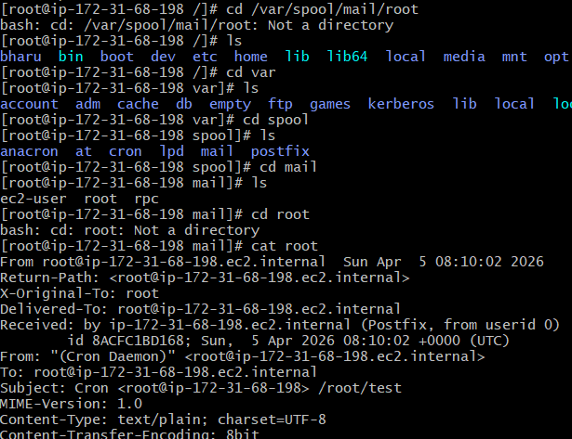
Check the number given is odd or even?
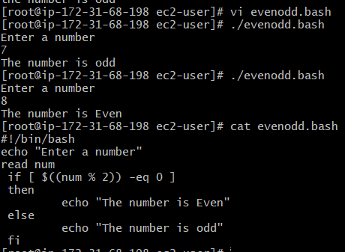
Declare a variable and print?
